Alumni Login Instructions

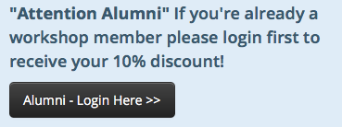
- Click the Alumni - Login Here >> button on the register page

2. That takes you to the login page where you enter your email / password:
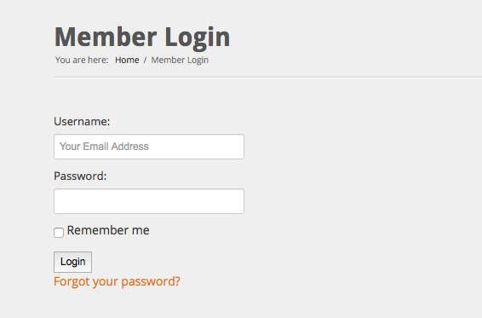

3. Once logged in - you will be directed to the workshop schedule

If you need to reset your password - click the forgot your password link under the Login Button Then follow instructions on next page.
Forgot Password Instructions:

- Go to this link (Or from step 2 on previous page): https://dhsolutionsinc.com/index.php/secure/forgot

2. Enter your email address - click Submit

3. You will get an email with password reset link (check your SPAM folder if you don’t see it).
Click the reset link

4. That will take you to this Reset password page - enter your new password and click
submit:
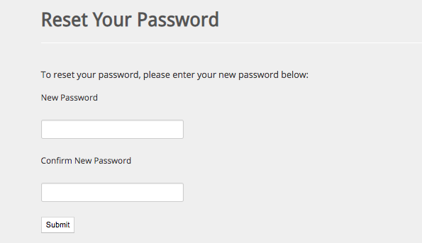

5. You will then go to a reset complete page. Now you can go to page 1 of this instruction sheet and login on the register page.

—- If you have any issues reseting password pls email kyle@funktiondesign.ca for assistance.

